IIITD&M Kancheepuram

**Problem solving and programming**

**Date: 24 JAN 2021**

**Duration: 01 Hr. Total Marks: 20**

1. What is the output for the following program? Justify your answer properly

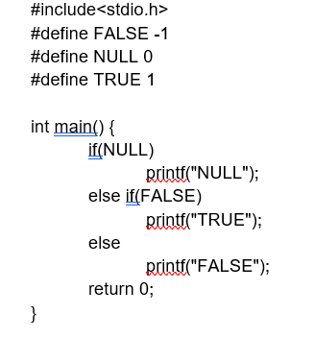

1. Find the output of the below program

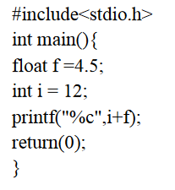

1. What is the output printed for the below statement if the value of c is 7 assigned by

#define c 7

printf(“%d”, (++c) - (c++) );

1. What are the values of ‘Stat’ and ‘var’ after executing the below statement assuming the variable

‘var’ is initialized with 7

Stat =( (++var + var-- << 3 ) >> 2) + var--

1. If the initial value of x is 96, what would be the value of x after performing the following statements respectively

x += 2;

and x =+ 2;

1. How many times program will be printed

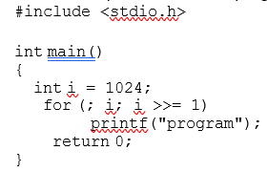

‘

1. Two’s complement represent of -17 is

8. What are the characteristics of an algorithm?

1. The hexadecimal representation of 657 base 8 is
2. Convert the octal number 0.5051 into its equivalent decimal number.